Serial No:
Final Exam
Total Time: 3 Hour
Total Marks: MRKS
________________
Signature of Invigilator

EE-227 Computer
Logic Design
Wednesday, June 17th , 2015
Course Instructor
Dr. Ayub Alvi, Dr. Fuleah Razzak and
Mr. Jawad Hassan

______________________________ _________ ______ _____________________
Student Name Roll No Section Signature

DO NOT OPEN THE QUESTION BOOK OR START UNTIL INSTRUCTED.
Instructions:
- Attempt on question paper. Attempt all of them. Read the question carefully, understand the question, and then attempt it.
- No additional sheet will be provided for rough work. Use and mark the back of the last page for rough work.
- If you need more space write on the back side of the paper and clearly mark question and part number etc.
- After asked to commence the exam, please verify that you have 16 pages different printed pages including this title page. There are total of 4 Questions.
- Calculator is NOT allowed.
- Use permanent ink pens only. Any part done using soft pencil will not be marked and cannot be claimed for rechecking.
- For each question show your complete method in solution.

 | Q-1 | Q-2 | Q-3 | Q-4 | Total
Total  Marks | 30 |  |  | 35
Marks Obtained

Vetted By: _____________________________ Vetter Signature: _____________________

Question # 1[3 + 3 + 6 + 6 + 6 +6 = 30]

- Reduce the following expression to three literals. [3]
A'C' + ABC + AC'

- Convert (776.625)8 to binary and then convert the resulting binary number to hexadecimal. Show your method. [3]

- Using two (2 x 4) decoders, enable and external gates design a combinational circuit defined by following two functions. [6]
- F1(x,y,z) = ( y + z' )x’
- F2(x,y,z) = ∑(1, 3, 4, 5)

- Implement following function with a 4x1 multiplexer. [6]
F(A,B,C,D) = ∑(0,2,3,6,9,12,14,15)

- A 4-bit magnitude comparator circuit is shown below: [6]
Give the expression for F(A<B). Label the output of all gates when comparing two numbers
A = 1000
B = 1010
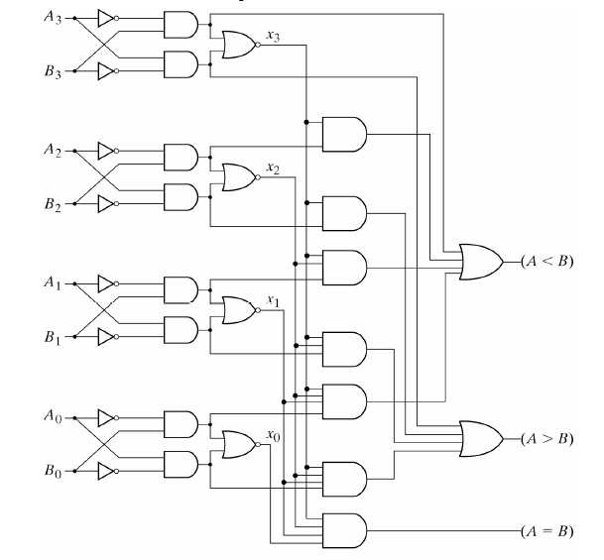

- Design a 4-bit priority encoder with following priority sequence. [6]
D₂ < D₀ < D₃ < D₁
Question # 2[4 + 9 + 10 + 12 = 35]
- Draw and label the circuit diagram of a positive edge triggered D-flip flop in master slave configuration using two D latch blocks. [4]

- A sequential circuit with two D flip flops, A and B; two inputs, x and y; and one output z, is specified by the following next state and output equations:
A (t+1) = x’y + xA’
B (t+1) = xB + y’A
z = B+x’y
- Draw the logic diagram of the circuit. [3]
- List the state table for the sequential circuit. [3]
- Draw the corresponding state diagram. [3]

- Analyze the following circuit with JK flip flops and provide the flip flop input equations, state table and state diagram. [10]

- Design a sequential circuit using T flip-flop by using following State transition diagram. Treat unused states as don’t cares. [12]

Question # 3[10 + 12 + 8 + 10 = 40]
- Design a two-bit counter using JK flip-flops which has one input x. [10]
When x=0, the counting sequence is 11, 01, 00, 10 and repeats.
When x=1, the counting sequence is 01, 11, 10, 00 and repeats.

- Design a 4 bit Modulo-9 counter (i.e. the counter goes up till 8 only and then goes back to 0). Clearly show all the design steps. Use only T-flip flops. Only diagrams as solution to this question are not acceptable. [12]
Note: Treat unused states as don’t cares.
- Draw and label the circuit diagram of a universal shift register using four 4 x 1 multiplexers and four D flip flops. The shift register should operate according to the following table. [8]
S1 | S0 | Operation
0 | 0 | Reset to 0
0 | 1 | Shift left
1 | 0 | Parallel Load
1 | 1 | Complement the input

- Students of Batch BSCS-2012 have developed a new flip-flop named LM Flip-Flop. When inputs of L and M are 00, 01, 10 and 11, the flip-flop is cleared to zero, complements, sets to 1, and no change occurs respectively. For LM Flip-Flop: [10]
  - Tabulate its characteristic table
  - Tabulate excitation table
  - Derive its excitation table
  - Construct D-type Flip-Flop using LM flip-flop.

Question # 4[15 + 10 + 10 = 35]
- Implement the following functions using a PLA with minimum number of product terms. construct PLA table and draw and label the PLA diagram clearly showing all the connections. [15]
F₁ (w,x,y,z) = Σ (2, 3, 4, 5, 6, 7, 10, 11)
F₂ (w,x,y,z) = Σ (1, 3, 9, 11, 12, 13, 15)
F₃ (w,x,y,z) = Σ (1, 4, 6, 7, 9, 12, 14, 15)
F₄ (w,x,y,z) = Σ (0, 2, 5, 7, 8, 10, 13, 15)

- Implement the following functions using the PAL. Construct PAL table and draw PAL diagram. [10]
NOTE: Functions are treated as simplified.
W(A,B,C,D) = ABC’ +B’CD’
X (A,B,C,D) = A + BD
Y(A,B,C,D) = ABC’ + B’CD’ + AC’D’ + A’B’C’D
Z (A,B,C,D) = A’B + CD + B’D’

- Implement following functions using 16 X 4 ROM. Give the ROM table and Draw the circuit. [10]
F₁ (A,B,C,D) = A' C' + B' D' + ABC
F₂ (A,B,C,D) = B' C + ACD + A' B C'
F₃ (A,B,C,D) = C' D' + CD + A' BC + AC' D'
F₄ (A,B,C,D) = BC' + BCD' + ABC

